
Basic Engineering Sciences-1
Data structures
I/IV-B.Tech-(II Sem), Academic Year: 2024-2025

Session-12 (Binary search tree operations insert delete and search)
Instructional Objective:
- To learn the concept of Binary search tree
- To implement the operations on BST
Learning Outcomes:
- Able to solve the tree traversals
- Able to find insert and delete and search operations
Introduction:
In a binary tree, every node can have a maximum of two children but there is no need to maintain the order of nodes basing on their values. In binary tree, the elements are arranged in the order they arrive to the tree from top to bottom and left to right.
Explanation:
To enhance the performance of binary tree, we use special type of binary tree known as Binary Search Tree. Binary search tree mainly focuses on the search operation in binary tree. Binary search tree can be defined as follows...

Binary Search Tree is a labeled binary tree data structure which has the following properties:

• The left subtree nodes with keys lesser than the parent node key.
• The right subtree nodes with keys greater than or equal to the parent node key.
• The left and right subtree each must also be a binary search tree

Example: 1
Construct a Binary Search Tree by inserting the following sequence of numbers...

10, 12, 5, 4, 20, 8, 7, 15 and 13
Above elements are inserted into a Binary Search Tree as follows...

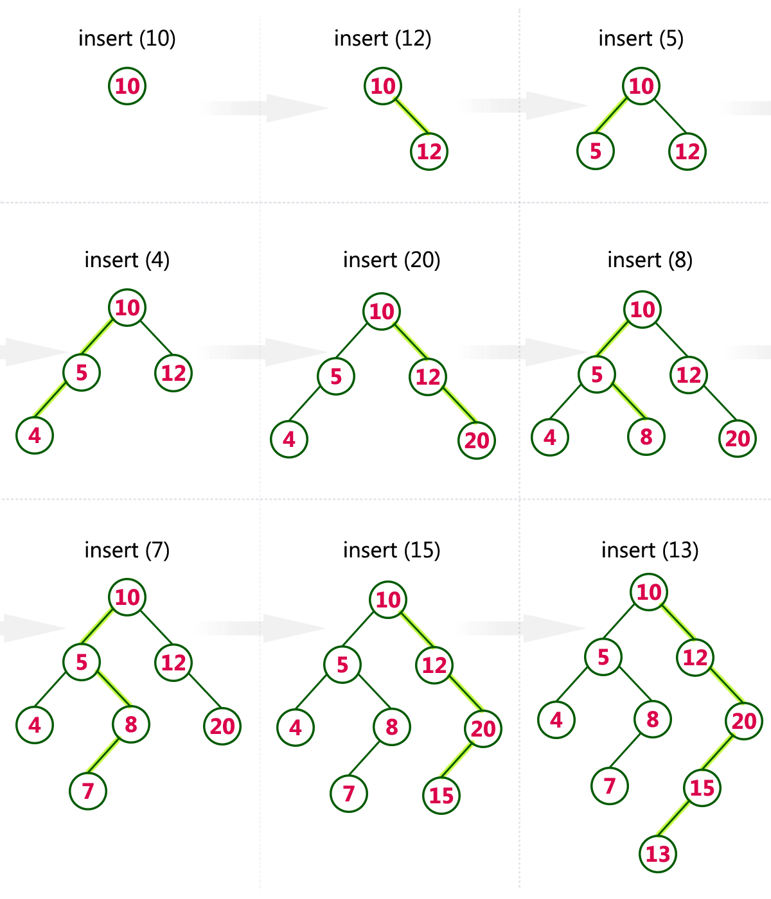

Following are the basic operations of a binary search tree −

• Search − To search an element in a tree.

• Insert − To inserts an element in a tree.

• Delete − To delete an element in a tree.

• Pre-order Traversal − To traverses a tree in a pre-order manner.

• In-order Traversal − To traverses a tree in an in-order manner.

• Post-order Traversal − To traverses a tree in a post-order manner

• FindMin − To find smallest element in a tree.

• FindMax − To find Largest element in a tree.

Search Opeartion:

For searching a given key in the BST,

• Compare the key with the value of root node.
• If the key is present at the root node, then return the root node.
• If the key is greater than the root node value, then recur for the root node’s right subtree.
• If the key is smaller than the root node value, then recur for the root node’s left subtree.

Example:

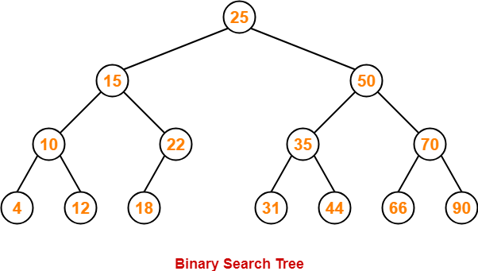

Review questions:
- Consider key = 45 has to be searched in the given BST
Consider key = 18 has to be searched in the given BST
Summary:
In binary search tree the basic operations are Search − To search an element in a tree, Insert − To inserts an element in a tree, Delete − To delete an element in a tree. Pre-order Traversal − To traverses a tree in a pre-order manner. In-order Traversal − To traverses a tree in an in-order manner. Post-order Traversal − To traverses a tree in a post-order manner. FindMin − To find smallest element in a tree. FindMax − To find Largest element in a tree.

Self-assessment questions:
1. Which of the following is false about a binary search tree?
a) The left child is always lesser than its parent
b) The right child is always greater than its parent
c) The left and right sub-trees should also be binary search trees
d) In order sequence gives decreasing order of elements
2. What is the speciality about the in-order traversal of a binary search tree?
a) It traverses in a non-increasing order
b) It traverses in an increasing order
c) It traverses in a random fashion
d) It traverses based on priority of the node

Terminal questions
CLASSROOM DELIVARY PROBLEMS
- Implement the binary tree traversals
- implement the binary search tree operations
- insert key 30 in the given binary search tree
- implement the search operations and delete operations
PRACTICE PROBLEMS
- Construct a binary search tree with the below information. The pre order traversal of a binary search tree 10, 4, 3, 5, 11, 12.
- What will be post order traversal of a binary Tree T, if pre order and in order traversals of T are given by ABCDEF and BADCFE respectively?
- A binary search tree is formed from the sequence 6, 9, 1, 2, 7, 14, 12, 3, 8, 18. The minimum number of nodes required to be added in to this tree to form an extended binary tree is?
- A binary search tree is generated by inserting in order the following integers:
50, 15, 62, 5, 20, 58, 91, 3, 8, 37, 60, 24
The number of the node in the left sub-tree and right sub-tree of the root, respectively
- write a function to implement binary search tree insertion operations
- write a function to implement delete operation of 3 cases
- write a function to implement the tree search operation
- Implement the tree traversals in BST

